Algebra 2 Name: ________________________________________
Graphing Quadratics – Vertex Form Date: _______________________ Period: ___________

Given the graph of a quadratic, state all the important information.

1.)

Opens: ______________________

Axis of Symmetry: _____________

Vertex: ______________________

Max/Min: ____________________

Domian: _____________________

Range: ______________________

Directrix: ____________________

End Behavior: Latus Rectum: ________________

$As x→∞,f(x)→$ ____________ Focus: ______________________

$As x→-∞,f(x)→$ ___________ Directrix: ____________________
__________________________________________________________________________________________________
Graph each quadratic equation. State all the important information
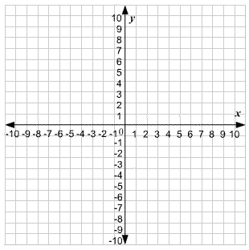
2.) $y={-2\left(x-3\right)}^{2}+5$

Opens: ______________________

Axis of Symmetry: _____________

Vertex: ______________________

Max/Min: ____________________

Domian: _____________________

Range: ______________________

Directrix: ____________________

End Behavior: Latus Rectum: ________________

$As x→∞,f(x)→$ ____________ Focus: ______________________

$As x→-∞,f(x)→$ ___________ Directrix: ____________________
3.) $y={\frac{1}{2}\left(x+2\right)}^{2}-3$

Opens: ______________________

Axis of Symmetry: _____________

Vertex: ______________________

Max/Min: ____________________

Domian: _____________________

Range: ______________________

Directrix: ____________________

End Behavior: Latus Rectum: ________________

$As x→∞,f(x)→$ ____________ Focus: ______________________

$As x→-∞,f(x)→$ ___________ Directrix: ____________________

__________________________________________________________________________________________________
4.) $y=4{\left(x-1\right)}^{2}-9$

Opens: ______________________

Axis of Symmetry: _____________

Vertex: ______________________

Max/Min: ____________________

Domian: _____________________

Range: ______________________

Directrix: ____________________

End Behavior: Latus Rectum: ________________

$As x→∞,f(x)→$ ____________ Focus: ______________________

$As x→-∞,f(x)→$ ___________ Directrix: ____________________

5.) $y={-3\left(x+2\right)}^{2}+8$

Opens: ______________________

Axis of Symmetry: _____________

Vertex: ______________________

Max/Min: ____________________

Domian: _____________________

Range: ______________________

Directrix: ____________________

End Behavior: Latus Rectum: ________________

$As x→∞,f(x)→$ ____________ Focus: ______________________

$As x→-∞,f(x)→$ ___________ Directrix: ____________________

__________________________________________________________________________________________________
6.) $y={-\frac{1}{3}x}^{2}+2x-7$

Opens: ______________________

Axis of Symmetry: _____________

Vertex: ______________________

Max/Min: ____________________

Domian: _____________________

Range: ______________________

Directrix: ____________________

End Behavior: Latus Rectum: ________________

$As x→∞,f(x)→$ ____________ Focus: ______________________

$As x→-∞,f(x)→$ ___________ Directrix: ____________________

