Name: _______________________

Starbucks Pricing

Background:
Starbucks is seeking to introduce the “Trenta” - their 30oz size of any beverage.
As they are deciding on prices, two executives are arguing over which should be more expensive -- the Caffe Misto or the Full-Leaf Brewed Tea.

Task:
Recommend a price for the Caffe Misto Trenta and for the Full-Leaf Brewed Tea Trenta.
Support your solution using sound mathematical reasoning.
With your group, come up with initial estimates for the prices. Write them below.

Caffe Misto Trenta (30 oz.) estimated price: __________

Full-Leaf Brewed Tea Trenta (30 oz.) estimated price: __________

Resources:
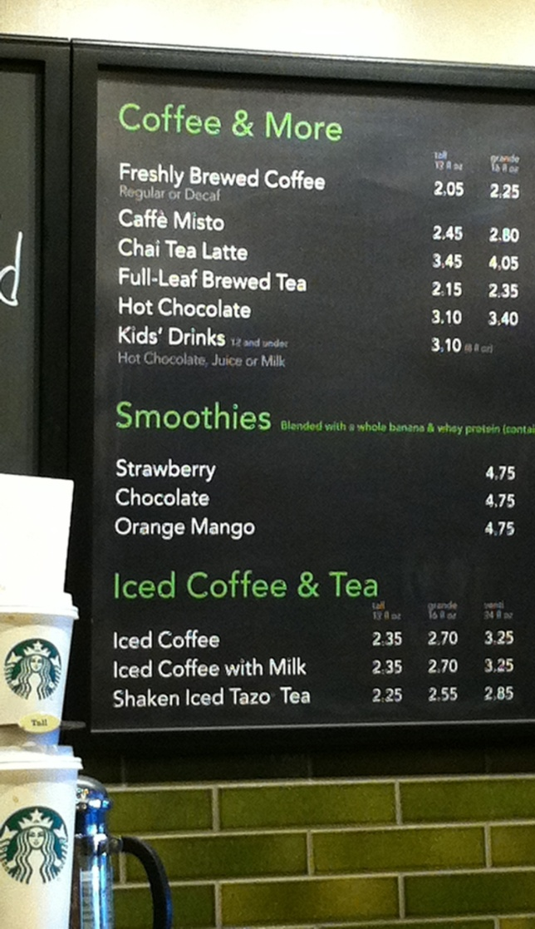
Starbucks currently offers the following sizes:
- Tall = 12oz
- Grande = 16 oz
- Venti = 20 oz

Here is a portion of the current menu -->

Group Accountability:
Demonstrate adequate mathematical reasoning to support your recommendation.

Individual Accountability: Any member of the group should be able to explain the logic behind any of the conclusions that the group has made.

Brainstorm: What could you do to help you start to solve this problem? Write down any ideas your group comes up with.

Part 1: Plot points and Label Axes
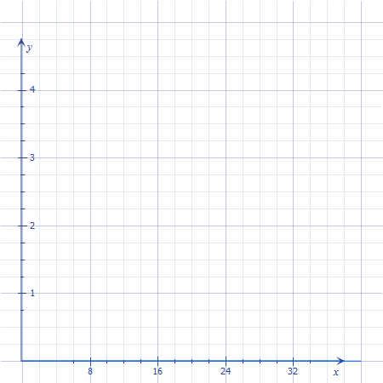
Extension #1

1. Do you see any patterns? If so, what do you see?

2. How does plotting points help you to determine the prices for the new drink size?

3. Predict a reasonable price for a venti sized Café Misto and a venti sized Full-Leaf Brewed Tea.

4. At what size do you think that the Tea and the Caffe Misto should have the same price?
Back up your argument using sound mathematical reasoning.

Part 2: Writing an Equation

Extension #2

1. Write an equation for the Café Misto.

2. Write an equation for the Full-Leaf Brewed Tea.

3. What do the slope and y-intercept represent in each situation?

Slope:

Y-int:

4. What does rate of change mean in the context of this problem?

5. Use your equations to predict the prices of new “Trenta” sized variations of the two drinks. Show mathematical reasoning.
“Café” “Tea”

6. Do your predictions agree with the graph you generated, if we followed the pattern? Explain.

Exit Slip Question – Summarizing Your Learning

Name__________________________

Drawing from words in the word bank below, describe the process you followed to determine your recommendation for the prices of either drink. (Pick one drink, but describe how you found prices for the 20 oz venti and the 30 oz trenta).
You might also include anything else you concluded today during class.

Word Bank
Line Ordered Pair X-Value Y-Value
Rate Ounce(s) Dollars Independent Variable
Dependent Variable Input Output Equation
Graph Model Forecast Predict
Solve Linear Function Slope

