Honors Algebra 2 Name: _________________________________
Solving Systems of Inequalities Date: ________________________ Period: ___

Solve each System of Inequalities by Graphing.

1.) $x-2y<6$ 2.) $x+2y≤10$
$-3x-2y≥10$ $x>-3$

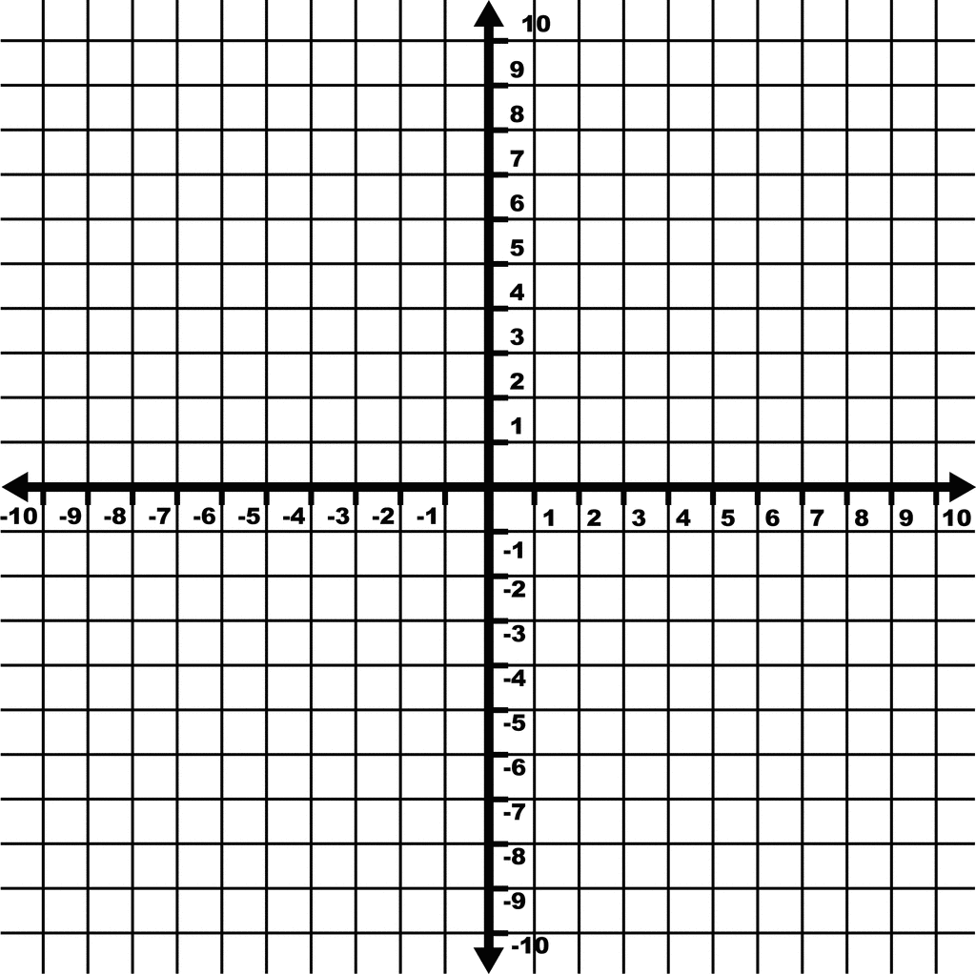

3.) $x-y<-5$ 4.) $2x+2y≤-6$
$3x+y<-2$ $3y≥3x+9$

5.) $4x-3y<9$ 6.) $6x+2y>-6$
$y<2$ $-8x+6y<12$

7.) $2x+4y<16$ 8.) Write an equation of a line that is
$y≥-3$ perpendicular to $y=\frac{2}{3}x-\frac{5}{12}$
$x>-1$ and passes through the point (8, 3).

