**Algebra II Gobble – Gobble ___________________**

**Turkey Review Date _________________________**

1.) Our school wanted to order new t-shirts for spirit wear with the new logo but was having trouble

choosing a company to place their order with. One company, Bruell’s Beauty, charges $9.65 per shirt plus a setup fee of $43. Another company, Shadel’s Suave, charges $8.40 per shirt plus a $58 fee.

A.) Write an equation that represents each company. Let $C$ stand for cost and $s$ stand for number of t-shirts.

Bruell’s Beauty Shadel’s Suave

_______________________________________________________________________________________________

B.) For what number of shirts would the cost be the same?

C.) Which company would be better to use if your school was planning on purchasing 200 t-shirts? Explain.

_______________________________________________________________________________________________

2.) If $g\left(x\right)={2x}^{2}-3x+5$, find $g\left(2a-1\right)$

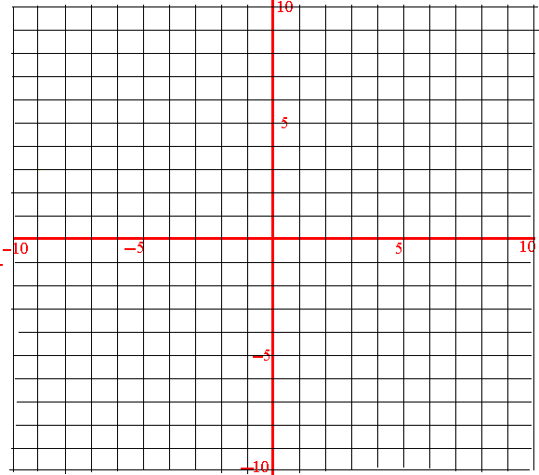3.) Graph $f\left(x\right)=x^{5}+{2x}^{2}-x-2$

Degree: _______________

End Behavior:

________________________________

________________________________

Zeros: ________________

R. Max: _______________

R. Min: _______________

Intervals Increasing: ______________________

Intervals Decreasing: ______________________

_______________________________________________________________________________________________

4.) Simplify:

A.) ${\left(5m-4n\right)}^{2}$ B.) $\left(4x^{3}-6x^{2}+7\right)-\left(15-2x^{3}+6x^{2}+4x\right)$

_______________________________________________________________________________________________

5.) Solve the following system of equations:

$x-y+3z=-8$

$2y-z=15$

$3x+2z=-7$



6.) Chad decides to try out for the USA Olympic Super Trampoline Team. In order for Chad to make the team he must perform a Quadruple Double Tuck Backward McShaky Side Shimmy jump in 5.8 seconds after leaving the trampoline (a feat that only one other person can perform, yours truly, Mr. Falinski). Chad knows he will have to launch himself at 19.6 meters per second (m/s) from the trampoline. Alex, his equation manager, who is a sleep 90% of the time, calculates that the height $s$ at time $t$ seconds after his launch is modeled by the equation $s\left(t\right)=-4.2t^{2}+24.6t+2.2$, where $s$ is in meters.

A.) What was the initial height that Chad began his ridiculously awesome Shimmy from?

B.) When will Chad reach the peak of his Shimmy?

C.) What will be the peak of Chad’s Quadruple Double Tuck Backward McShaky Side Shimmy?

D.) When will Chad land his Shimmy?

E.) Will it be in enough time to make the team? Explain in full sentences

F.) When will Chad reach 22 meters in his Quadruple Double Tuck Backward McShaky Side Shimmy?

_______________________________________________________________________________________________

[](http://images.google.com/imgres?imgurl=http://picture-book.com/files/userimages/1047u/happyturkey.jpg&imgrefurl=http://picture-book.com/taxonomy/term/3126&usg=__fzsGcRGDi37r1lkxZ3ZrgcNvgro=&h=700&w=549&sz=55&hl=en&start=3&tbnid=gzdKriQsCeDlVM:&tbnh=140&tbnw=110&prev=/images?q=humorous+turkey&gbv=2&hl=en&safe=active&sa=X)

7.) Find the remainder when $z^{5}-{3z}^{2}-20$ is divided by .

[](http://images.google.com/imgres?imgurl=http://farm3.static.flickr.com/2080/2052840316_159564c210.jpg&imgrefurl=http://www.flickr.com/photos/13864123@N07/2052840316/&usg=__U6Q6_MKS6ZaIH4cQLX7dAgA7Gd4=&h=500&w=333&sz=98&hl=en&start=6&tbnid=4YS1tNDkpr8jaM:&tbnh=130&tbnw=87&prev=/images?q=humorous+turkey&gbv=2&hl=en&safe=active&sa=X)8.) Find $k$ so that $-3$ is a root of $2x^{2}+kx-27=0$.

__________________________________________________________________________________________________

9.) Solve Algebraically and Graphically.

$y=\frac{1}{2}{\left(x+4\right)}^{2}-6$

$y=3x+2$

A.) Algebraically B.) Graphically



Solution(s): ____________________________ Solution(s): _____________________________

10.) Find all zeros given $x=2$ is a zero to the following equation: $x^{3}-4x^{2}+6x-4=0$

Zeros: ____________________________________

11.) Find $f\left(2x-3\right)$ for the following function:

$f\left(x\right)=-3x^{2}+4x-8$

_________________________________________________________________________________________________

12.) Multiply: $\left(7-5i\right)\left(7+5i\right)\left(2-3i\right)$

__________________________________________________________________________________________________

Find all of the rational zeros for each function.

13.) $f\left(x\right)=x^{4}-x^{3}+x^{2}-3x-6$# of Zeros: __________

|  |  |  |
| --- | --- | --- |
| Positive Real Zeros | Negative Real Zeros | Imaginary Zeros |
|  |  |  |



Zeros: ______________________________________

__________________________________________________________________________________________________

14.) If $k$ is constant, what is the value of $k$ such that the polynomial $k^{2}x^{3}-6kx+9$ is divisible by $x-1$?

15.) Sketch the following polynomial.

$f\left(m\right)=-\left(m-1\right){\left(m+4\right)}^{2}$

Lead Coefficient: _______________

Degree: ______________________

Zero(s): ______________________

End Behavior:

$as m →∞, f(m)→____________$

$as m →-∞, f(m)→___________$

Relative Max: _______________________________

Relative Minimum: ___________________________

Intervals Increasing: __________________________

Intervals Decreasing: __________________________

__________________________________________________________________________________________________

16.) In their spare time, your math teacher loves to build rectangular boxes. However, they need your help with this one. Your teacher wants to build a rectangular sheet of cardboard 15 inches by 25 inches. A small square of the same size is cut from each corner and each side is folded up along the cuts to form a lidless box.

A.) Sketch a picture of the rectangular sheet and label it correctly.

B.) What length of square should be cut from each corner that would maximize the volume, $V\left(x\right)$, of the box?

C.) What is the maximum volume, $V\left(x\right)$, of the box?

D.) Your teacher has one stipulation to the volume of the box. Your teacher wants to know what size of square would produce a box with a volume equal to 400 cubic inches. Show your work algebraically.

17.) A graphic artist is designing a poster that consists of rectangular print with a uniform border. The print is to be twice as tall as it wide, and the border is to be 3 inches wide. If the area of the poster is to be $680 in^{2}$, find the dimensions of the print.

A.) Sketch a picture of the rectangular print and label it correctly.

B.) Write an equation that shows the area of the poster is $680 in^{2}$.

C.) Find the dimensions of the print.

__________________________________________________________________________________________________

18.) Match the following functions to their corresponding graph.

______ ______ ______

______ ______ ______

______ ______

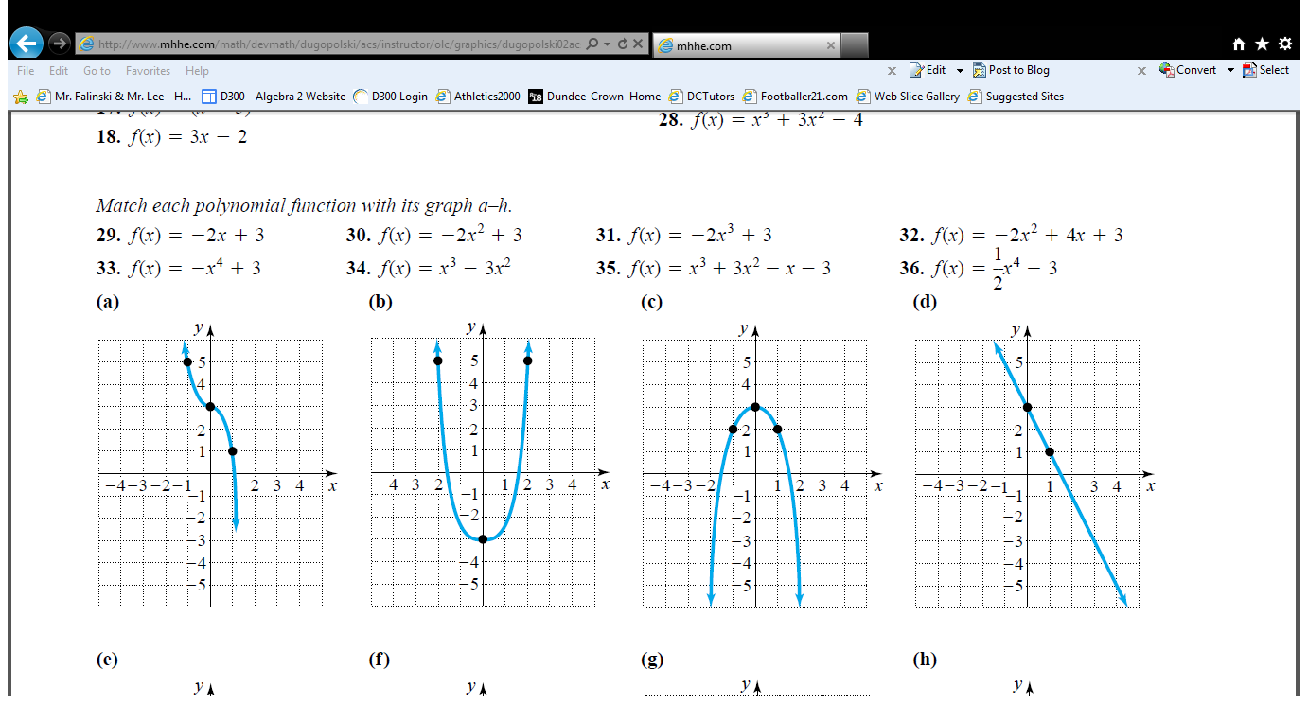

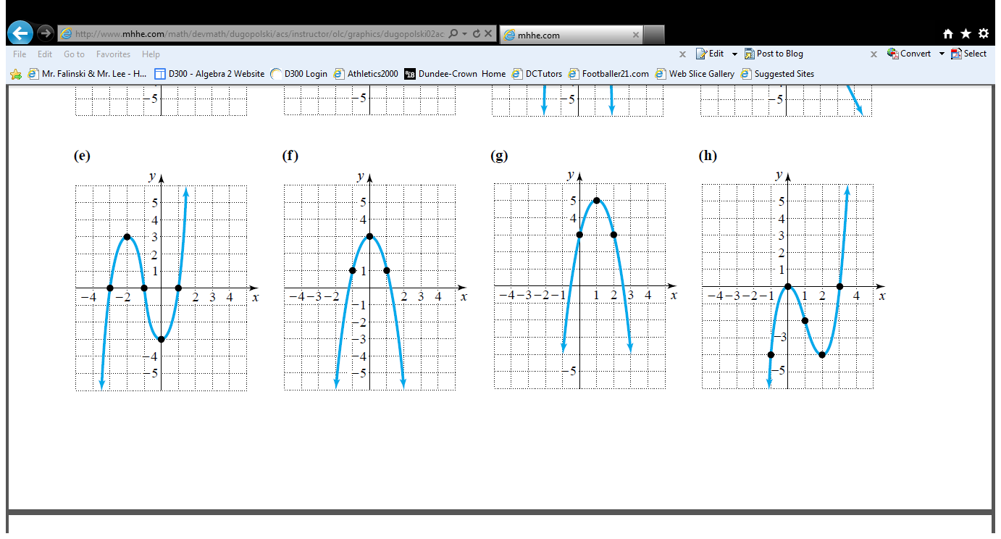

19.) What is the solution of the equation $\frac{2m^{2}+3m-5}{m^{2}+4m-5}=4$?

__________________________________________________________________________________________________

20.) The table shows several complex numbers, where $i$ is the imaginary unit. Place an “x” in all appropriate cells in the table where the product of the two numbers is a real number.

|  |  |  |  |
| --- | --- | --- | --- |
|  | $$8-2i$$ | $$3$$ | $$i$$ |
| $$8+2i$$ |  |  |  |
| $$5i$$ |  |  |  |
| $$-4$$ |  |  |  |

__________________________________________________________________________________________________

21.) An expression is given: $x^{2}-8x+21$

Determine the values of $h$ and $k$ that make the expression ${\left(x-h\right)}^{2}+k$ equivalent to given expression.

$h=_______________$, $k=_____________$

__________________________________________________________________________________________________

22.) Solve. $x^{2}-8x+21={\left(x-4\right)}^{2}+3x-16$

23.) What is the solution of the system of linear equations?

$x-9y+4z=1$

$-2x+9y-4z=1$

$2x+y-4z=-3$

Solution: $( , , )$

__________________________________________________________________________________________________

24.) The expression $x^{2}{\left(x-y\right)}^{3}-y^{2}{\left(x-y\right)}^{3}$ can be written in the form ${\left(x-y\right)}^{a}(x+y)$, where $a$ is a constant. What is the value of $a$?

__________________________________________________________________________________________________

25.) If $\sqrt{\sqrt[3]{{\left(x+1\right)}^{5}}}={\left(x+1\right)}^{a}$, for $x≥-1$, and $a$ is a constant, what is the value of $a$?

__________________________________________________________________________________________________

26.) The functions $f$ and $g$ are defined by $f\left(x\right)=x^{2}$ and $g\left(x\right)=2x$, respectively. Rewrite the function

$h\left(x\right) = \frac{f\left(2x\right)g\left(-2x\right)}{2}$ in terms of $x$.

27.) For each system of equations shown in the table, determine the number of points of intersection. Select one cell for each row.

|  |  |  |  |
| --- | --- | --- | --- |
| System | No Points of Intersection | One Point of Intersection | Two Points of Intersection |
| $$y=1-x^{2}$$ $$y=x-1$$ |  |  |  |
| $$y=1-x^{2}$$ $$y=1$$ |  |  |  |
| $$y=1-x^{2}$$ $$y=2-x$$ |  |  |  |

__________________________________________________________________________________________________

28.) Write the expression $x-xy^{2}$ as the product of the greatest common factor and a binomial. Then, determine the complete factorization of $x-xy^{2}$.

Product of greatest common factor and binomial: __________________________________________________

Complete Factorization: _______________________________________________________________________

__________________________________________________________________________________________________

29.) Consider the expression $6x^{3}-5x^{2}y-24xy^{2}+20y^{3}$.

A.) Which expression is equivalent to $6x^{3}-5x^{2}y-24xy^{2}+20y^{3}$?

a.) $x^{2}\left(6x-5y\right)+4y^{2}(6x+5y)$ b.) $x^{2}\left(6x-5y\right)+4y^{2}(6x-5y)$

c.) $x^{2}\left(6x-5y\right)-4y^{2}(6x+5y)$ d.) $x^{2}\left(6x-5y\right)-4y^{2}(6x-5y)$

B.) Which expression are factors of $6x^{3}-5x^{2}y-24xy^{2}+20y^{3}$? Circle ALL that apply.

a.) $x^{2}+4y^{2}$ b.) $6x-5y$ c.) $x+2y$

d.) $6x+5y$ e.) $x-2y$

30.) Consider the function $f\left(x\right)=(2x-1)(x+4)(x-2)$.

a.) What is the $y-intercept$ of the graph of the function in the coordinate plane?

b.) For what values of $x$ is $f\left(x\right)>0$? Express your answer on the number line.

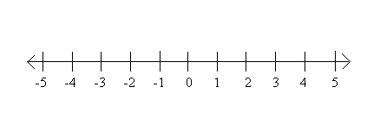

c.) What is the end behavior of the function above?

$As x →∞, f(x)→____________$

A $s x →-∞, f(x)→___________$

d.) How many relative maximums does the function have?

a.) none b.) one c.) two d.) three

__________________________________________________________________________________________________

THERE IS NO BETTER STUFFING THAN MATH STUFFING!!!!!!!!!!!!

