Learning Target : I can use tables, graphs, and equations to describe linear functions and make a prediction.

Linear Equations from Tables, Graphs & Parameters

Equations are a useful way to describe certain patterns in tables and graphs. Equations allow you to decide whether a value matches the rest of the pattern, or to make predictions based on the pattern. Linear equations are important to master—they are used by everyone, the patterns are easy to detect, and the equations are easy to use. In this activity, you examine situations that show a linear pattern, describe them with an equation, and then use the equation to make predictions.

I Have a Code

Code-talkers have known for a long time that you can use math to invent coding processes. For example, suppose your number the letters of the alphabet according to their alphabet order, so that ‘A’ is 1, ‘B’ is 2, etc. A mathematical rule is then used to create the code values that are shown in the Figure 1 table:

Alphabet Letter | A | B | C | D | E | F | Etc.
Position Number (P) | 1 | 2 | 3 | 4 | 5 | 6 | :
Code Value (C) | 5 | 8 | 11 | 14 | 17 | 20 | :
Figure 1.

- By only looking at the table entries, how do you know that the coding process that was used can be described by a linear equation?

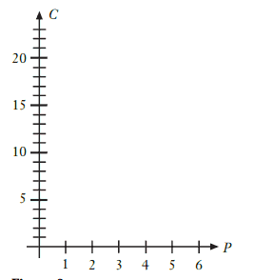

- Make ordered pairs of the form (P, C) using all the data in the table.

  - Graph the ordered pairs on a grid like the one in Figure 2.
  - Explain how the pattern in your graph shows that the coding process uses a linear equation. Include the line as part of your graph.

Figure 2
- To find the equation for the coding process, you need to know the slope.
  - What is the slope of the line that you drew in Question 2? Explain how you got your answer.

  - How would you determine the slope from the table values in Figure 1?

  - Use the slope formula with the ordered pairs (3, 11) and (6, 20) to calculate the slope of your line.

- The other thing that the equation needs is the y-intercept.
  - How can you use the table values in Figure 1 to find the y-intercept?

  - Does the graph that you made verify your location for the y-intercept? Explain.

  - Work with the slope-intercept equation form (y = mx + b), your answer from Question 3 and the ordered pair (4, 14) as values for x and y. Find the value for the y-intercept. Explain your method.

- Recall that the slope-intercept form is one way to state a linear equation. You will need to use your answers to Questions 3 and 4.

  - What is the equation used for the coding process? Explain.

  - The 20th letter of the alphabet is ‘T’. Use your equation to determine the code value for ‘T’. Show your calculations.
  - Does someone writing a message with this coding process ever work with a code value of 55? Use your equation to explain why or why not.

The Cost of Doing Business

EZAccess, a new phone company, offers this service plan: $10 per month, and 8 cents per minute for all calls made at any time. To help decide if this plan is a good deal, you can use mathematics to examine the relationship between the number of minutes spent on the phone (t) and the number of dollars you pay for the phone service (C).

- First, it may be helpful to explore the problem with some specific situations.

  - If you do not make any calls during the month, how much do you pay?

  - If you make 50 minutes worth of phone calls, how much do you pay?

  - If you make 100 minutes worth of phone calls, how much do you pay?

  - If the phone service costs you $19.60 for the month, how many minutes have you spent on the phone? Show mathematical proof.

- At this point, you might wonder if the relationship between minutes used and total cost is linear.

  - Record your answers from Question 1 in appropriate places in a table similar to the one in Figure 3.
Time (minutes) | 0 | 50 | 100
Cost (dollars) |  |  |  | $19.60
Figure 3.

  - Examine the table values. Is the relationship that describes this situation linear? Explain your reasoning, or show a calculation to support your answer.

  - From the problem description alone, can you tell whether the relationship is linear? Explain.

  - You may have noticed a pattern in the way the first three pairs of table values increase, but that the same pattern does not hold for the last pair. Does that mean that a different relationship was used to create the last pair? Explain.

- You can now express the relationship between the two variables as an equation.

  - What equation calculates the cost, C, from the number of minutes used, t? Explain how you got your answer.

  - For how many minutes did you talk in a month, if the phone service cost $22.00?

  - In this situation, what is the meaning of each of the constants in your equation? Explain.

Additional Practice

- A cartoon animator creates the effect of motion by drawing an object in different locations at different times. The locations are standardized by using the same coordinate system in each drawing. The table in Figure 4 is an example (the origin is the lower-left corner of each drawing).
t (sec) | x (cm) | y (cm)
0 | 6 | 22
1 | 9 | 21
2 | 12 | 20
3 | 15 | 19
4 | 18 | 18
13 | ?? | ??

  - What equation describes the horizontal location, x, with respect to the time, t?

  - What equation describes the vertical location, y, with respect to the time, t?
Figure 4

  - What equation describes the vertical location, y, in terms of the horizontal location, x (the actual motion of the object)?

  - What is the location (both x- and y-coordinates) of the object at the end of 13 seconds of travel?

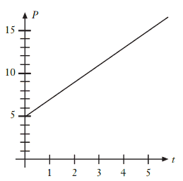

- Wildlife biologists study the population growth of animal species. In one study, a herd of moose was monitored. The data that were collected are shown as a graph in Figure 5, where P is the moose population and t is the number of years since the study began.
  - What equation describes the growth of the moose population over time?

Figure 5
  - If the same growth pattern continues, how many years would it take for the population to be 23 moose?

- Keith wants to sell pizza at a flea market on Thursday nights. He plans to buy pizza for $0.75 per slice and sell it for $1.25 per slice. He must pay $20.00 to rent a booth.
  - Suppose he sells 24 slices of pizza. Does he make money or lose money? Explain.

  - How many slices must he sell to make a profit of $6.50?

- The table in Figure 6 tracks the amount of money in an interest-free savings account at the end of each month after deposits are made.

Number of Months | Account Balance
0 | $220
1 | $250
2 | $280
3 | $310
4 | $340
Figure 6
If the deposit pattern continues, how much money is in the account after 3 years?

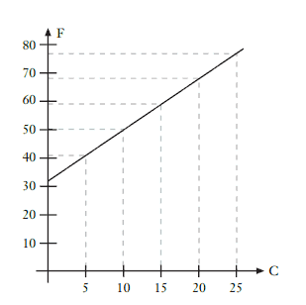
- The Figure 7 graph shows the conversion from degrees Celsius (°C) to degrees Fahrenheit (°F).
  - According to the graph, what is the rule that converts from Celsius to Fahrenheit? In other words, what equation describes °F in terms of °C?

  - What is 35°C in Fahrenheit degrees?

Figure 7

- A taxi costs $1.50 for the first 1/10 of a mile and an additional $0.15 for each 1/10 mile. Which of these equations describes the cost of the fare, C, in terms of the number of miles traveled, m?
  - C = 1.50m + 0.15
  - C = 0.15m + 1.50
  - C = 0.15m + 1.35
  - C = 0.15(m + 1.50)

- The air temperature affects the rate at which a cricket chirps. The Figure 8 table contains some data.
Chirps per Minute | 20 | 40 | 60
Temperature (C) | 10 | 14 | 18
Figure 8.

At what temperature would the crickets chirp 75 times per minute?

- 19 b) 21 c) 22 d) 26

- A business sells tickets for major league baseball games. Various costs for an upper-deck reserved seat are shown in the Figure 9 table.
Number of Tickets | 1 | 2 | 3 | 4
Cost (in dollars) | $20.50 | $38.50 | $56.50 | $74.50
Figure 9.

What equation describes the pricing scheme—the relationship between the cost, C, and the number of tickets purchased, n?
    - C = 18.00n
    - C = 20.50n
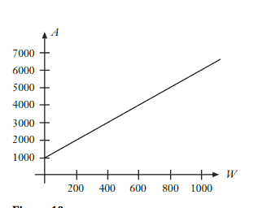
    - C = 20.50 + 18.00n
    - C = 2.50 + 18.00n

- A trucking firm charges customers according to the graph shown in Figure 10.

If W is the weight (in pounds) and A the amount charged (in dollars), what equation is used to calculate the amount charged?
  - A = 5000W + 1000
  - A = 1000W + 5000
  - A = 5W + 1000
  - A = 1000W + 5
Figure 10

- A local county fair charges $6.00 for admission, and $0.50 per ride. If 3 friends spend a total of $28.50, how many ride tickets did they purchase?

- 7 b) 15 c) 21 d) 45

